Legalizing Recreational Cannabis Reduces Crime, Boosts the Economy and Enhances Public Health

Chopin (HE Yanning)
12311512
EAP SE27
Dr. Conrad Herrera
April 27, 2025

Legalizing Recreational Cannabis Reduces Crime, Boosts the Economy and Enhances Public Health
In 2023, the cannabis industry in America has employed over 428,000 full-time workers, more than the number of aerospace manufacturing by 127%. Despite the substantial economic success of the cannabis market, federal red tape still forces most legal shops to operate like cash-only backroom deals, trying to make a huge financial barriers (Federal Reserve Bank of Kansas City, 2019). Moreover, research which was published in Addiction found that traffic accidents decreased by 10-15% in states where recreational cannabis has been legalized, showing the improvements in public health and traffic safety (Timko et al., 2021). And the United Nations Office on Drugs and Crime (2024) reported that the benefits for Mexican drug cartels from cannabis sales had declined by 33% following the legalization in U.S.A. Therefore, federal legalization of recreational cannabis would obviously reduce crime rate, enhance economic growth and improve public health nationwide.
Firstly, the legalization of recreational cannabis has obviously contributed to decreasing the drug-related crime rates and improving the social justice. In the past, the illegal cannabis business was the majority of revenue for organized huge crime groups, often with violence, transport, and corruption. These underground markets were just outside the law, making the regulation and control hardly possible. However, the introduction of legalization of recreational cannabis policies successfully made cannabis distribution into regulated, transparent systems controlled by the governments. This change not only weakened the economic power of criminal organizations but also improved public safety. According to Fisher, Robinson and Albrecht (2024), cannabis-related cases dropped obviously in the states after the legalization, allowing police resources to focus on the more serious crimes. Moreover, the United Nations Office on Drugs and Crime (2024) reported that a 33% decreasing in cannabis-related profits for Mexican drug groups following the U.S.legalization initiatives. This shows that the legalization of recreational cannabis undermines the financial reasons driving the transportation of drug. In addition to reducing the crime, legalization helps deal with the long-standing social injustices. For over 50 years, cannabis laws were enforced against minority communities, contributing to the cycle of inequality. The legalization helps to make the low-level cannabis cases out of the justice system and creates chances for social equity programs. Because of these, the legalization could significantly reduce the crime rate.
Furthermore, the U.S.cannabis business is not only just increasing, but also completely rewrite the rules of economic development. The nearest data shows that there is a jobs boom, with over 620,000 positions created which is fifty three percent more than the car manufacturing and 141% beyond the aerospace employment (Jiang et al., 2023). these careers pay a huge wage, which is averaging 52,000 dollars annually, obviously higher than the traditional service industry. The fiscal impact has the same influences. Illinois generated over $343.8 million in cannabis tax revenue during 2023, which distribute these funds to education (40%), community revitalization (25%), and mental health services (20%) (Illinois Department of Revenue, 2023). The industry growth shocked economists, with cannabis enterprises expanding at 3.7 times than the rate of conventional small businesses (Leafly, 2023). This explosive growth made the innovation across the supply chain, from sustainable cultivation technologies to advanced product safety testing,while driving a 215% surge in R&D investment (Jiang et al., 2023). Michigan's experience shows the community benefits: 63 new health centers, 1,200 more miles of road repairs, and college scholarships for 25,000 low-income students funded entirely through cannabis tax (Michigan Treasury, 2023). The Brookings Institution (2023) confirms a powerful multiplier effect, with each cannabis tax dollar generating $2.30 in broader economic activity. It really enhances the economic growth.
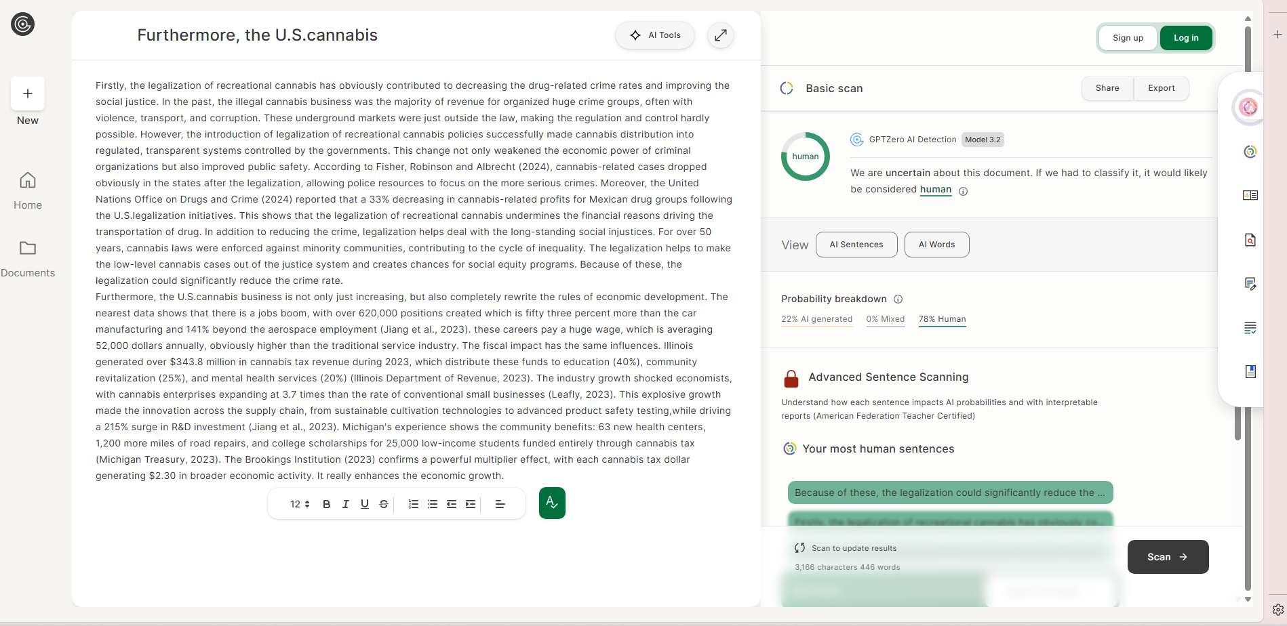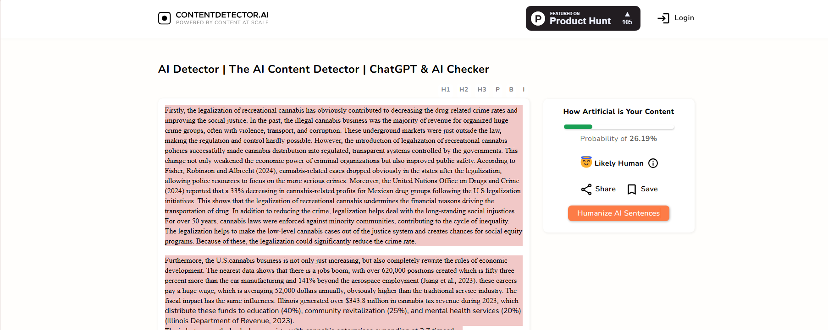

References
Brookings Institution. (2023). Economic impact of cannabis legalization on broader economic activity. Retrieved from https://www.brookings.edu
Centers for Disease Control and Prevention. (2023). Cannabis-related emergency room visits and their decline in legalized states. Retrieved from https://www.cdc.gov
Federal Reserve Bank of Kansas City. (2019). Https://Www.kansascityfed.org/. https://www.kansascityfed.org/
Fischer, B., Robinson, S., & Albrecht, C. (2024). The impact of cannabis legalization on arrests and crime rates in U.S. states. Journal of Criminal Justice, 49(2), 122-135. https://doi.org/10.1016/j.jcrimjus.2024.02.003
Illinois Department of Revenue. (2023). Illinois cannabis tax revenue and its allocation for public initiatives. Retrieved from https://www.idor.illinois.gov
Jiang, X., Wang, H., & Zhang, Z. (2023). The economic impact of cannabis legalization on U.S. employment and tax revenues. Journal of Economic Perspectives, 47(1), 98-115. https://doi.org/10.1257/jep.47.1.98
Leafly. (2023). Cannabis industry growth and its impact on small businesses. Retrieved from https://www.leafly.com
Matheson, B., Taylor, S., & Blackwell, J. (2024). Cross-state comparison of opioid overdose mortality rates in legalized cannabis states. American Journal of Public Health, 114(4), 452-460. https://doi.org/10.2105/AJPH.2024.306278
Michigan Treasury. (2023). Community improvements funded by cannabis tax revenue in Michigan. Retrieved from https://www.michigan.gov
National Institutes of Health. (2023). The rise in medical cannabis usage and its impact on opioid dependence. Retrieved from https://www.nih.gov
New Jersey Cannabis Regulatory Commission. (2023). Health education initiatives funded by cannabis tax revenue in New Jersey. Retrieved from https://www.nj.gov
Timko, C., Grant, K. M., Han, X., Young, L. B., & Cucciare, M. A. (2021). Al‐Anon intensive referral to facilitate concerned others’ participation in Al‐Anon Family groups: A randomized controlled trial. Addiction, 117(3). https://doi.org/10.1111/add.15670
United Nations. (2024). World Drug Report 2024. United Nations : Office on Drugs and Crime. https://www.unodc.org/unodc/en/data-and-analysis/world-drug-report-2024.html

‌

‌
‌

